Faculty of Computer Science & Engineering
CS343 - Data Science (Elective)
Semester Project Report



Project Title:
M.A.R.S [Metric Augmented Retrieval System]

Student Information:
 | Student Name | Student Reg # | Student Degree
Student-1 | Nazaar Khalid | 2023485 | Software Engineering
Student-2 | Nawal Jabeen | 2023570 | Software Engineering

Submission date: ______________________
Submitted To: ______________________

Table of Contents
Project Title: 1
Problem Statement 3
The Solution 4
Dataset Description 4
Methodology 5
Stage 1: Data Engineering 5
Starting point: 5
Preprocessing and Duplication: 5
Heuristic Data Recovery: 5
Unit Standardization & Feature Engineering 5
Statistical Validation (The IQR Purge): 6
Visual profiling and Giant Hunting: 6
Serialization for AI ingestion: 6
Stage 2: Post-EDA 6
Vision AI & JSON enforcement: 6
Constraint Engineering and LLM prompt: 7
Fig 1.0 - Image shows prompt fed to Gemini to control LLM’s spatial reasoning 7
RAG Bridge : 7
Stage 3: RAG & 3D Engine Bridge 8
Orchestrator.py(The Execution Pipeline) 8
Infinigen Blender Utilities(butil.py) 8
Stage 4: Smart 3D Assembly Engine(mars_lib) 8
Results 10
Test- 1: Coffee-table 10
Test- 2: Office-table 12
Test- 3: Circular Base Table 13
Test- 4: Bed with Backrest 15
Test- 5: Armchair 16
Dashboards 19
Dashboard 1: Raw Data Exploration 19
Dashboard 2: Data Pipeline Validation 20
Dashboard 3: Physical Characteristics of Assets 21
Conclusion 22

Problem Statement
With the rise of Generative AI and spatial computing, there is a growing demand for automated 3D asset generation. However, while Vision AI models are great at identifying components from images, e.g., (Cushioned Seat, 4 legs, etc.), they lack structural intuition and physical constraints, resulting in hallucination.
Using an AI-generated JSON of metrics and coordinates in a 3D asset results in physically broken models, Z-clipping issues, floating parts, and disjointed geometry. The core problem here is that AI provides independent spatial approximations, whereas 3D asset generation requires dependent architectural logic (e.g., an armrest rests at approximately half the height of a backrest)
Moreover, real world furniture data is incredibly messy, full of missing values and incorrect dimensions, and when fed to a 3d generator, can build inaccurate assets.
Hence, there is a critical need for a structural middleware that takes AI data and pre-built architectural functions and dynamically resolves them into structurally sound and mathematically perfect 3d geometry.

The Solution
M.A.R.S is an automated pipeline built in Python for Blender that fixes both the data and geometry. It acts as a smart builder by:
1. Uses RAG for search and fetching real world dimensions of Ikea furniture
2. Utilizes Gemini Vision to identify furniture as well as extract a “Recipe” -i.e., Components of identified furniture
3. Accesses a library of Python functions(mars_lib.py) that make use of bpy (Blender Python) and Infinigen- robust Blender utilities for abstracting away tedious bpy.
By making use of these 3 components, it assembles structurally perfect, VR ready 3D-models, scaled to real world dimensions.

Dataset Description
For the M.A.R.S pipeline, we started off with an IKEA products dataset sourced from Kaggle. It began with 3.6k+ rows and 14 columns of raw data. It featured columns including :
- Identifiers: item_id, name.
- Dimensions: width, height, depth.
- Category: text labels specifying furniture type(bed, chair), helpful for grouping.
- Description: Link to the product, used later on to find missing dimensions.
- Price: Current and Old price.
- Other columns, like colors and designer
The Dataset was transitioned into a JSON format during the final stage of the preprocessing pipeline. Unlike the flat CSV, the JSON structure allowed storing of clean dimensions (width_m, height_m, depth_m) alongside rag_content strings that the MARS pipeline uses for furniture placement logic.
The final JSON pristine file contains approximately 1.5k items that serve as the single source of truth for M.A.R.S. JSON file contents include:
- item_id
- name
- Category: i.e Bar furniture, Beds
- Rag_content: Product Name and Categories with Description and Dimensions
- Physical Dimensions: (Width ,Depth, Height )

Methodology

Stage 1: Data Engineering

Starting point:
We started off with IKEA Products Dataset sourced from Kaggle that initially had 3.6k+ rows and 14 columns. The challenge lay in the fact that the data was in centimeters and contained unnecessary data e.g. price data and feature duplicated item_ids for color variants. Moreover nearly one third of the items were missing at least one critical dimension(Width, Height or Depth).

Preprocessing and Duplication:
The price and unnamed columns were dropped as they did not serve the 3d engine. The dataset was deduplicated; using Python(Pandas) the data was grouped by item_id. If a furniture had 10 color variants only the first instance was kept.

Heuristic Data Recovery:
Missing dimensions were recovered by using Regex, A search pattern [ (\d+)x(\d+) cm ] was written to scan the rag_content and description strings to extract hidden dimensions (e.g parsing “51x40cm” from a text string), successfully reducing 300 items that would have otherwise been discarded.

Unit Standardization & Feature Engineering
The entire dataset was converted from commercial units (cm) to engineering units(m) . This was achieved through
- Feature Engineering:
- Three new dimension columns were created (width_m, height_m, depth_m).
- A column rag_content made up of Product name, category, and description.
- Linear Scaling: A transformation was applied where Value(meters) = Value(cm) / 100. This was critical because 3D world coordinates in VR typically treat 1 unit as 1 meter.

Statistical Validation (The IQR Purge):
At this point, Junk categories were dropped (having fewer than 5 items) and physical impossibilities were removed by using:
- IQR(interquartile range), We calculated the 25th(Q1) and 75th(Q3) percentiles for all dimensions.
- Outlier Range: A safe zone was defined using Q3 + 1.5 * IQR. Any item where W,D, H was < 0.05m was flagged as an outlier and dropped.
This resulted in a pristine library of approximately 1.8k items. And removal of nearly 400 noisy items.

Visual profiling and Giant Hunting:
Seaborn plots were generated to visually inspect the dimensional distribution (W,D ,H) across all categories. Rough physical volume was calculated (w*d*h) to identify and isolate the single largest item in every category- the Giants.
The visual EDA revealed the largest items surviving were Modular Systems (e.g a sectional sofa) . These broke the 3D pipeline as they were not singular objects.
Subsequently a strict text filter was implemented to drop any row containing keywords like combination, sectional, system , module or wall unit.
A cap was implemented as final safety so that no item was wider than 2.6m or deeper than 2.2m. This helped guarantee 3D viability.

Serialization for AI ingestion:
The final validated table was converted into a format the RAG agent could read. This was done using JSON mapping and the cleaned dimensions and product dimensions were concatenated into a rag_content string that allows the LLM to perform keyword based semantic scoring.
The final result was an ultra clean, dense and validated JSON Library with approximately 1.5k standalone furniture items.

Stage 2: Post-EDA
With the ikea_rag_pristine.json cleaned and validated the next step was to bridge the RAG data pipeline with the Vision LLM and format the output so it perfectly feeds into the Component Dispatcher.

Vision AI & JSON enforcement:
Fragile Regex text-parsing was eliminated and the Vision LLM was forced to output bulletproof machine-readable data.
- Vision extraction was transitioned to gemini-2.5 flash
- A try/except safety net was built to catch format hallucination by the LLM
- The LLM was forced to separate its output into 2 strict dictionaries : search_params(for the RAG database) and component_recipe (for the 3D engine)

Constraint Engineering and LLM prompt:
The system uses a prompt to force the AI to classify furniture using:
- Strict objects(surface, support, backrest, armrest, base, storage_box)
- Universal Modifiers: (is_cushion, z_position ratio, scale_w, scale_d, thickness_ratio, thickness_m, pitch angle, x_position, y_position)
- Logic GuardRails : Physical Constraints to prevent 3D engine from attempting impossible geometry e.g (Bed cannot have storage)

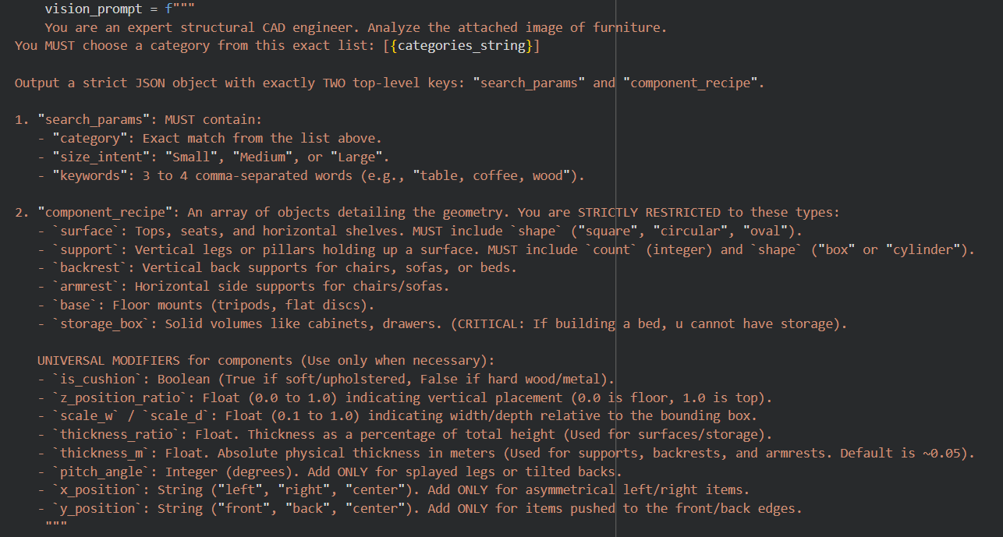

Fig 1.0 - Image shows prompt fed to Gemini to control LLM’s spatial reasoning

RAG Bridge
At this stage the real world scale from the database was merged with structural blueprints from the Vision AI. The search_params from the LLM output were directly fed into the retrieve_ikea_metrics smart scoring function to pull the most accurate real-world dimensions from the pristine database.
The RAG database (overall_bounding_box) and the Vision AI’s structural blueprint (component_recipe) were stitched together into a single, unified payload. ( mars_payload_[filename].json ) That was fed to the orchestrator for the most exciting part of the pipeline : 3D furniture generation.

Stage 3: RAG & 3D Engine Bridge

Orchestrator.py(The Execution Pipeline)
The orchestrator acts as the dispatcher for MARS. It is a bridge between the generated payload and the library of python functions for furniture generation(mars_lib). It imports blender python (bpy) and mars_lib and injects the current directory into the system path.
It starts by clearing the blender workspace before a new build is initiated using the bpy command to select all and delete. The orchestrator then receives the json payload which is made up of the bounding_box (W, D, H) and component_recipe. This payload is injected into the mars_lib.build_from_recipe() function which sends these metrics to mars_lib to pick and choose from functions.
Once mars_lib completes the geometric assembly, the orchestrator then handles file formatting and extraction. It packages the scene into a .glb VR-ready file that is sent to the M.A.R.S outputs folder in the drive where it can be downloaded and used.
This ensures total automation and decouples 3D assembly from RAG.

Infinigen Blender Utilities(butil.py)
Native Blender Python is highly verbose and prone to low level context errors. Hence Project MARS makes use of Infinigen, specifically its butil (blender utilities) library- for construction. This aids in :
- Instancing primitives like Cubes ,Cylinders etc
- Scaling primitives to calculated dimensions
- Ensures assets are production-ready by applying operations such as bevel to add curvature and catch light in rendering engines.

Stage 4: Smart 3D Assembly Engine(mars_lib)
The mars_lib.py acts as the geometric brain of the procedural generation pipeline. It has a library of functions for individual component generation curated to create physically viable 3D assets.

It consists of the following functions:
- clean_string(s) : Sanitizes raw data string coming from the JSON payload by forcing the string to lowercase so that types like OVAL don't break the string matching logic.

- spawn_surface: This function is responsible for generating flat structural planes such as tabletops and chair/ stool seats. It enforces proportion locks; for example if the AI requests a circular shape inside a rectangular bounding box, the script mathematically locks the X/Y dimensions to a minimum dimensions so a perfect circle is generated instead of an oval. Moreover it uses offset math to align the surface to the extreme front, back or centre of the bounding box.

- spawn_support: This function is responsible for generating legs/ supporting pillars. Being one of the most mathematically complex functions it works by determining the structural destination of the legs( stopping at surface for a tabletop or armless chair, or extending till armrests(for an armrest chair). Moreover if the surface is circular or oval it employs a trigonometric 0.707 multiplier to perfectly calculate leg placement at the perimeter of the ellipse.

- spawn_storage_box: This function is responsible for spawning solid geometric blocks for items like dressers, desk pedestals. It calculates the delta between the master bounding box and individual box’s scale to position items asymmetrically. Furthermore it assumes the object rests on a base (like a floor and shifts the mesh up by half its calculated thickness to prevent clipping into -ve Z space.

- spawn_base: This function generates stabilizing ground mounts such as heavy pedestal “discs”. It works by clamping maximum base size to 65 % of overall width to prevent massive bases.

- spawn_backrest: This function is responsible for generating vertical planes designed to cap the rear of a seating structure. Since 3D origins are mostly centre-based , placing an object at the back of a bounding box can cause floating components. This function solves this by calculating the read boundary and then pulls the mesh in by half its thickness. Moreover it subtracts seat height from bounding height so that the backrest sits neatly over the seat, preventing overlapping.

- spawn_armrest: This function generates the horizontal rails that bridge the front of the chair to the backrest. Since armrests are structurally dependent on the backrest, the function actively subtracts the backrest’s thickness from available depth and pushes the armrest forward. Similar to the backrest it uses the thickness halving match to snap left and right armrests to sit perfectly flush with the extreme outer X-axis boundaries.

- Build_from_recipe: This function acts as the central architectural compiler within MARS_lib. Rather than generating the geometry itself, it processes the JSON payload, establishes relationships and orchestrates execution of all individual spawn_ modules.
It works by initialising the root- an anchor that ensures the final asset is grouped into a single moveable hierarchy for the end user.
Then, it loops through the entire JSON to first map the structural context. During the scan, it checks for secondary structural constraints (like armrests). If an armrest exists then it dynamically calculates the absolute vertical midpoint between the seat and the bounding box ceiling (main_surface_z + ((1.0 - main_surface_z) * 0.5)).
After the scan, it routes each JSON component to the respective spawn_ function and actively injects the gathered context.

Results
A series of stress tests were carried out on the MARS pipeline to test its 3D asset generations. Five major tests highlight the efficiency of the MARS pipeline. The results are evaluated on the basis of the output from the RAG+Vision [ the JSON payload ] and the output from the MARS 3D Engine.

Test- 1: Coffee-table
Input Image:
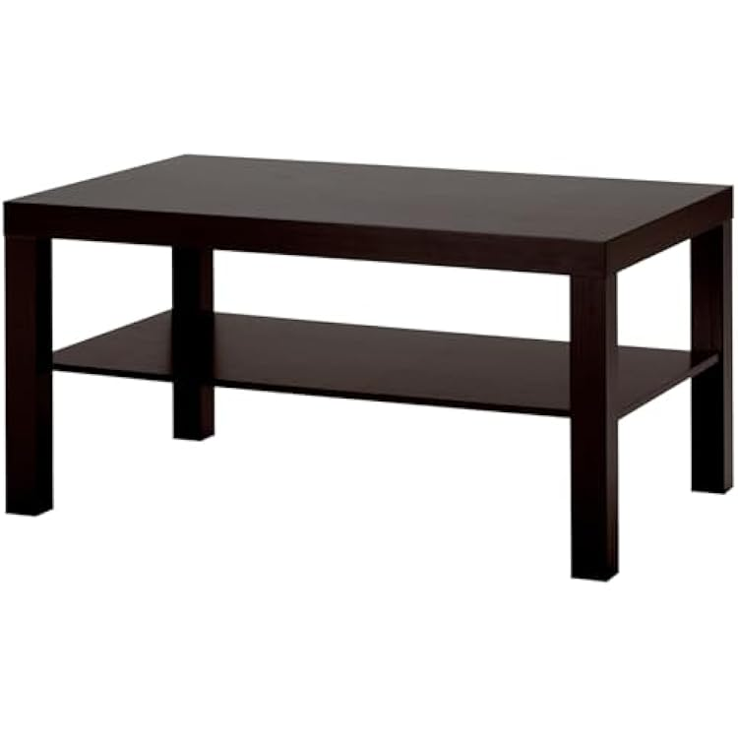
Generated JSON Payload:
{
"overall_bounding_box": {
"width_m": 1.18,
"depth_m": 0.6,
"height_m": 0.45
},
"component_recipe": [
{
"type": "surface",
"shape": "square",
"z_position_ratio": 1.0,
"thickness_ratio": 0.05
},
{
"type": "surface",
"shape": "square",
"z_position_ratio": 0.45,
"thickness_ratio": 0.05
},
{
"type": "support",
"count": 4,
"shape": "box",
"thickness_m": 0.06
}
]
}
Output(3D asset):
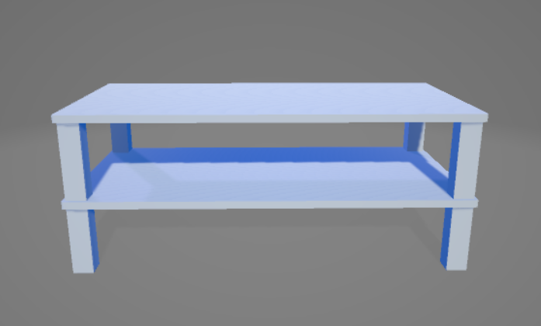

Test- 2: Office-table
Input Image:
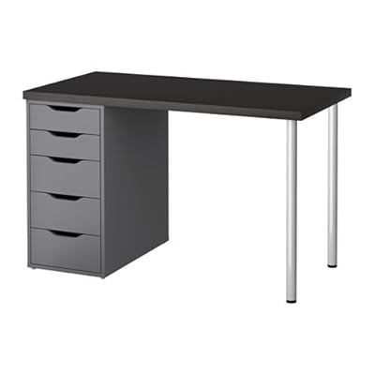
Generated JSON Payload:
test_payload = {
"overall_bounding_box": {
"width_m": 1.2,
"depth_m": 0.47,
"height_m": 0.75
},
"component_recipe": [
{
"type": "surface",
"shape": "square",
"z_position_ratio": 1.0,
"thickness_ratio": 0.03
},
{
"type": "storage_box",
"x_position": "left",
"thickness_ratio": 1.0,
"scale_w": 0.35,
"scale_d": 0.95
},
{
"type": "support",
"count": 2,
"shape": "cylinder",
"x_position": "right",
"thickness_m": 0.05
}
]
}
Output(3D asset):
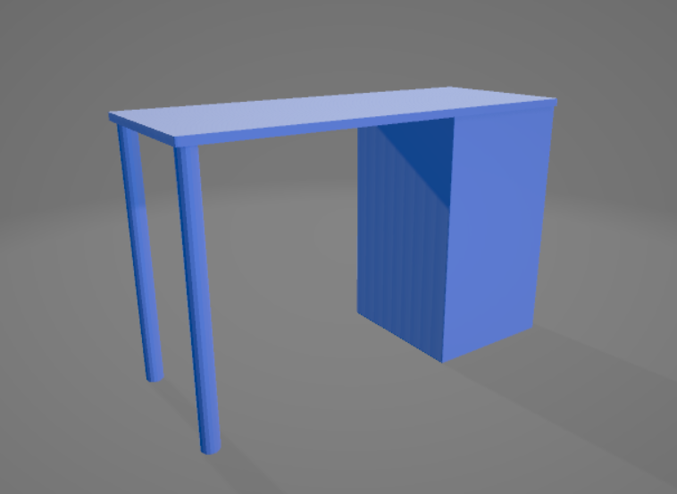

Test- 3: Circular Base Table
Input Image:

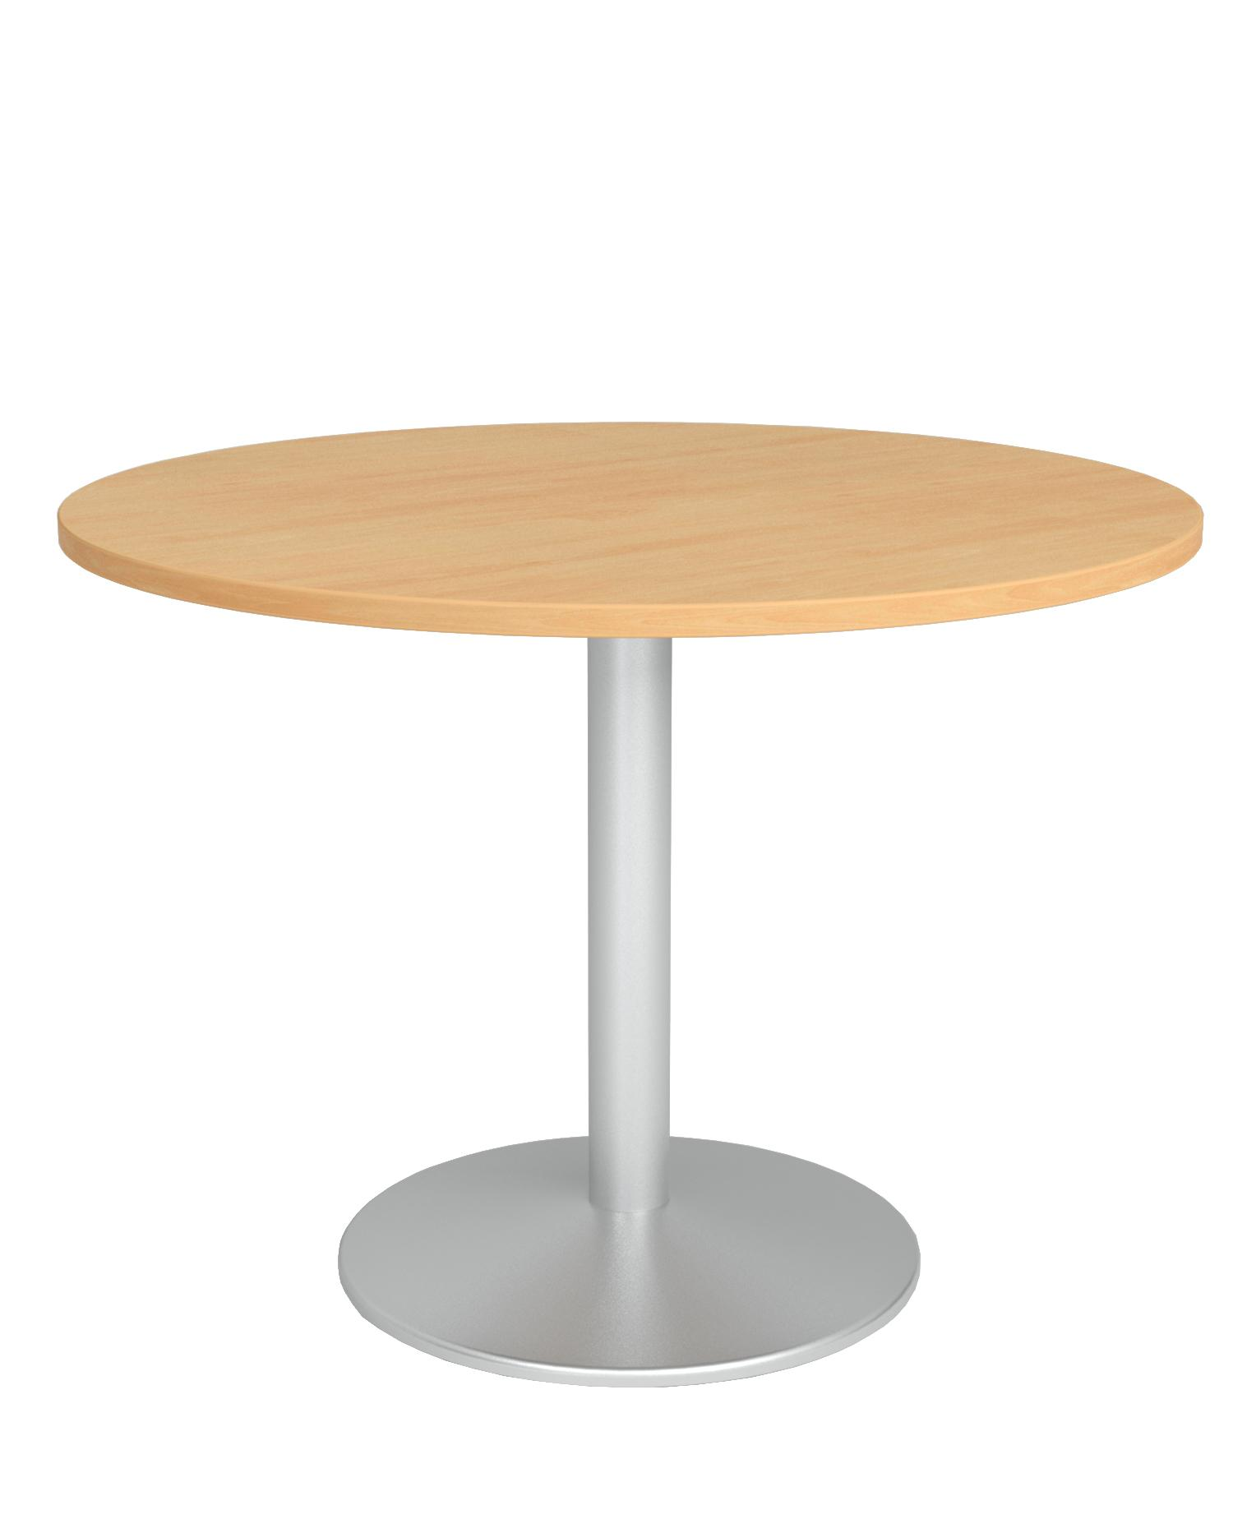
Generated JSON Payload:
{
"overall_bounding_box": {
"width_m": 0.83,
"depth_m": 0.83,
"height_m": 0.55
},
"component_recipe": [
{
"type": "surface",
"shape": "circular",
"z_position_ratio": 0.75,
"thickness_ratio": 0.04,
"is_cushion": false
},
{
"type": "support",
"count": 1,
"shape": "cylinder",
"thickness_m": 0.15
},
{
"type": "base",
"z_position_ratio": 0.02,
"thickness_ratio": 0.02,
"scale_w": 0.6,
"scale_d": 0.6
}
]
}

Output(3D asset):
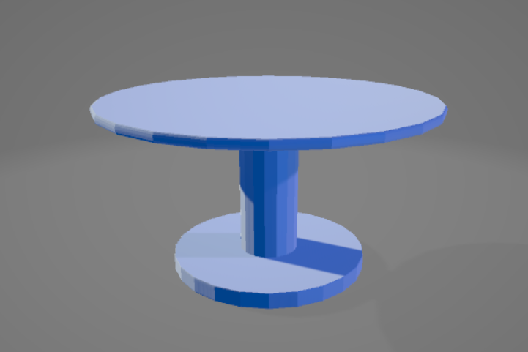

Test- 4: Bed with Backrest
Input Image:
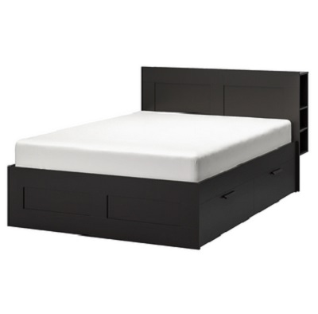
Generated JSON Payload:
{
"overall_bounding_box": {
"width_m": 1.6,
"depth_m": 2.0,
"height_m": 0.99
},
"component_recipe": [
{
"type": "surface",
"shape": "square",
"is_cushion": false,
"z_position_ratio": 0.2,
"scale_w": 1.0,
"scale_d": 1.0,
"thickness_ratio": 0.4
},
{
"type": "surface",
"shape": "square",
"is_cushion": true,
"z_position_ratio": 0.5,
"scale_w": 0.9,
"scale_d": 0.85,
"thickness_ratio": 0.2
},
{
"type": "backrest",
"is_cushion": false,
"z_position_ratio": 0.7,
"thickness_m": 0.05,
"scale_w": 1.0,
"y_position": "back"
}
]
}
Output(3D asset):
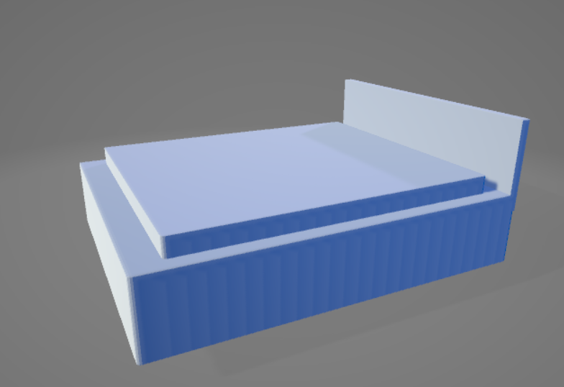

Test- 5: Armchair
Input Image:


Generated JSON Payload:
{
"overall_bounding_box": {
"width_m": 0.57,
"depth_m": 0.63,
"height_m": 0.99
},
"component_recipe": [
{
"type": "support",
"count": 4,
"shape": "box",
"thickness_m": 0.05
},
{
"type": "surface",
"shape": "square",
"is_cushion": False,
"z_position_ratio": 0.4,
"thickness_ratio": 0.05
},
{
"type": "armrest",
"is_cushion": False,
"z_position_ratio": 0.65,
"thickness_m": 0.04
},
{
"type": "backrest",
"is_cushion": False,
"thickness_m": 0.03
}
]
}
Output(3D asset):
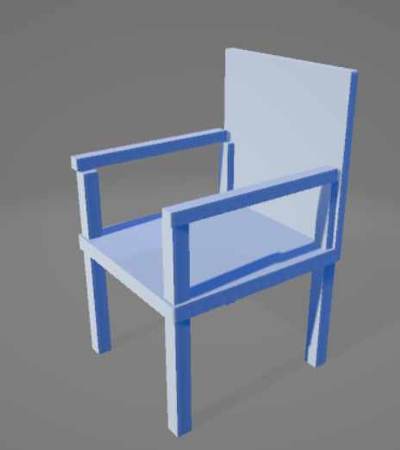

These results conclude that MARS was successfully able to construct 3D models.

Dashboards

Dashboard 1: Raw Data Exploration
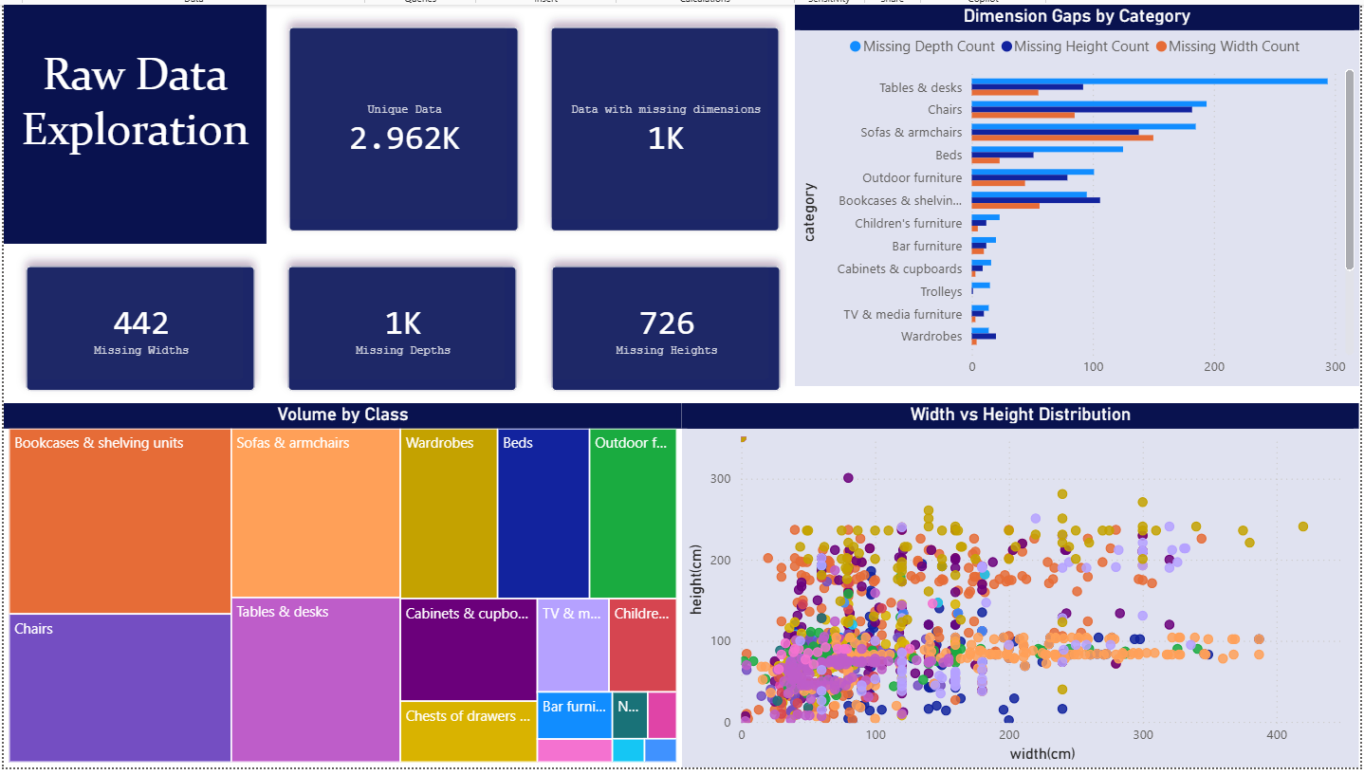
Dataset: Original Raw Ikea Dataset from Kaggle.
Raw data is messy; in order to determine cleanup methods to get a more usable data, we first visualize the mess. Upon analysis, we see an approximate of 33% of missing dimensions and extreme outliers.
- KPIs: Out of 2.96k unique items, about 1k of them are missing dimensions.
- Bar Chart (Dimension Gaps by Category): Furniture like tables and desks, chairs, and sofas suffer the most from missing data.
- Treemap (Volume by Class): Shows the volume and diversity of categories, as well as being a filter, along with a visualization.
- Scatter Plot (Width vs Height Distribution): Exposes outliers for each category (with the help of category filtering using the treemap). It’s clear to see the outliers must be dealt with to ensure proper dimension accuracy.
Conclusion: The dashboard confirms that the initial raw data will not perform well for a realistic furniture creation due to the missing data and extreme outliers. Although it also shows that the data has diverse enough categories to work with different types of furniture. Based on the visual diagnostic, we will:
- Drop/Fill in rows with missing dimensions.
- Deal with outliers using statistical filtering(Interquartile range).

Dashboard 2: Data Pipeline Validation
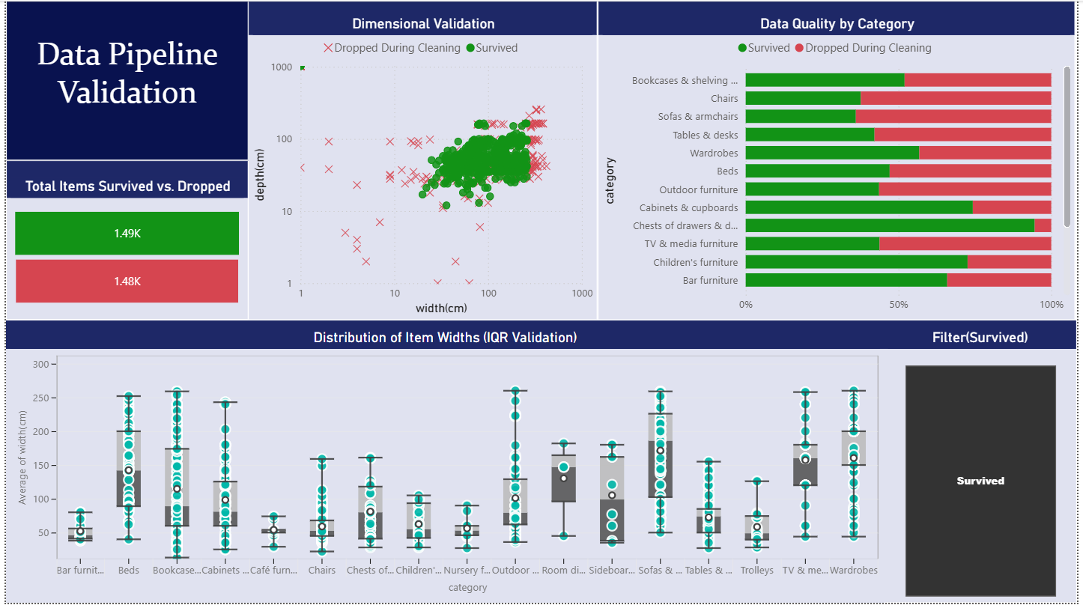
Dataset: Original Ikea Dataset and Final Preprocessed Dataset.
After the final dataset was created, we wanted to validate the effectiveness of the data pipeline. Upon analysis, about half of the dataset was dropped, ensuring quality over quantity.
- Funnel (Survived vs Dropped): Shows how much data remained and how much was dropped.
- Scatter Plot (Dimensional Validation): The green cluster shows the safe zone of realistic furniture dimensions, while the red zone shows outliers that were dropped.
- 100% Stacked Bar Chart (Quality by Category): Shows which categories were the most broken initially, i.e., Chairs, Sofas, etc.
- Box and Whisker (IQR Validation): Proves low dimension’s variance as compared to the original data.
Conclusion: This dashboard confirms that the pipeline worked as intended, noise and outliers were dealt with successfully, and the surviving assets were ensured to be set within realistic real world parameters.

Dashboard 3: Physical Characteristics of Assets
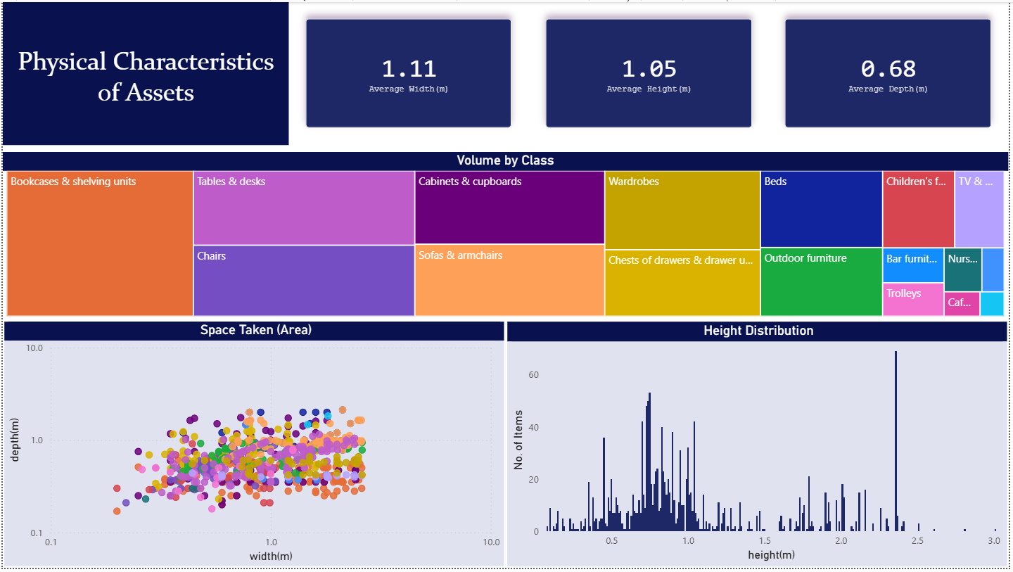
Dataset: Final Preprocessed Dataset.
A final dashboard, showing the ready to be used real world dimensions to ensure compliance with room space limits.
- KPIs: Average sizes for overall furniture as well as individual categories (filtered using the treemap).
- Treemap (Volume by Class): Shows the diverse categories of furniture, as well as used for filtering through categories.
- Scatter Plot (Space taken): Maps out how much floor space items take up, the perfect clustering confirms that the data has low variance.
- Histogram (Height Distribution): Distribution of heights across every product, useful in the 3D modelling stage where rooms may have a height limit to fit in furniture.
Conclusion: This dashboard is the final approval for the processed data. It is confirmed that the messy data has been converted into a more reliable dataset, hence it's finally ready for use in the 3D modelling stage.

Conclusion
Generative AI hallucinates, whereas physical architecture demands precision.
Project M.A.R.S bridges this gap by using an end to end pipeline that transforms noisy e-commerce data into 3D geometry. By pairing a pristine RAG database with the mathematical heuristics of the MARS 3D Engine, we let the engine do the heavy lifting of procedural generation. Project M.A.R.S helps to eliminate the hassle of spending time on manual 3D models and worrying about real world dimension scaling.

